|  |
| --- |
|  |
| Talk of Thrones |
| Axure Prototype Documentation |
|  |
| **Aakash Ramesh | Abishek Shrivastava | Kartikeya Mehta | Nikhil Nair | Udit Khanna** |
|  |

This document is to demonstrate the logic and the technicality behind the prototype. This document is an optional submission.

1. Pages
   1. Page Tree

Main Home  
Home  
 Houses  
 Page Setup  
 Profile Page GRE  
 Pre Game  
 Game 1  
 Game 2  
 Game 3  
 Game 4  
 Game 5  
 Game 6  
 Game 7  
 Game 8  
 Game 9  
 Game 10  
 Dashboard  
 Pop up for all  
 Winning Pop up  
 Subscription  
 After Subs  
Theories  
 Theory 2  
 Theory 3  
Shopping Page  
 Shopping Page 2  
 Cart  
Chat  
Chat page  
Assistance

* 1. Main Home
     1. User Interface



* + 1. Widget Table

|  |  |
| --- | --- |
| Footnote | Interactions |
| 1 | OnClick:  Case 1:  Open Main Home in Current Window |

* 1. Home
     1. User Interface

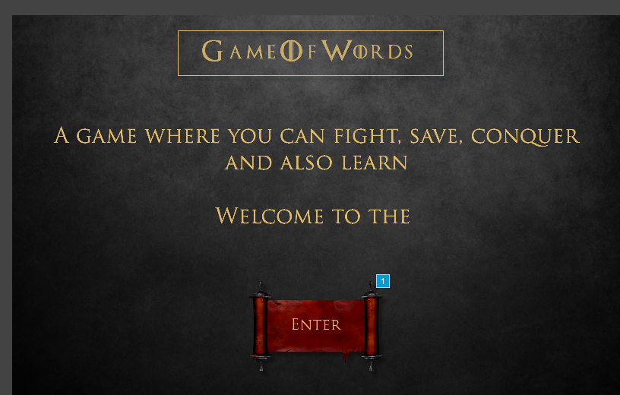

* + 1. Widget Table

|  |  |
| --- | --- |
| Footnote | Interactions |
| 1 | OnClick:  Case 1:  Open Houses in Current Window |

* 1. Houses
     1. User Interface

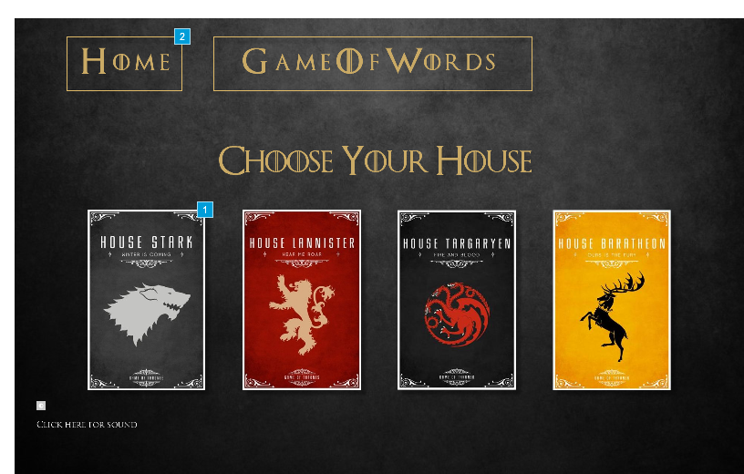

* + 1. Widget Table

|  |  |
| --- | --- |
| Footnote | Interactions |
| 1 | OnClick:  Case 1:  Open Page Setup in Current Window |
| 2 | OnClick:  Case 1:  Open Main Home in Current Window |

* 1. Page Setup
     1. User Interface

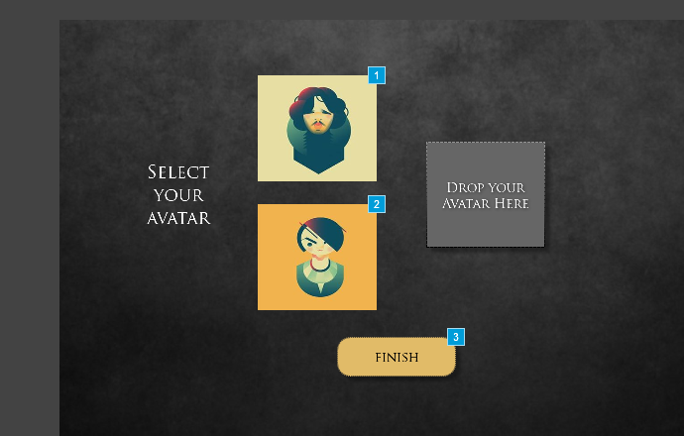

* + 1. Widget Table

|  |  |  |
| --- | --- | --- |
| Footnote | Name | Interactions |
| 1 | Jon Snow | OnMove:  Case 1  (If "[[DragX]]" equals "3"):  Set text on Unidentified equal to "3 YES!" OnDrag:  Case 1:  Move Jon Snow with drag OnDragDrop:  Case 1:  Set text on text value equal to "You are Jon Snow" |
| 2 | Arya Avatar | OnMove:  Case 1  (If "[[DragX]]" equals "3"):  Set text on Unidentified equal to "3 YES!" OnDrag:  Case 1:  Move Arya Avatar with drag OnDragDrop:  Case 1:  Set text on text value equal to "You are Arya stark" |
| 3 |  | OnClick:  Case 1:  Open Profile Page GRE in Current Window  Close Current Window |

* + 1. Jon Snow
       1. State1
       2. User Interface



* + 1. Arya Avatar
       1. State1
       2. User Interface



* 1. Profile Page GRE
     1. User Interface

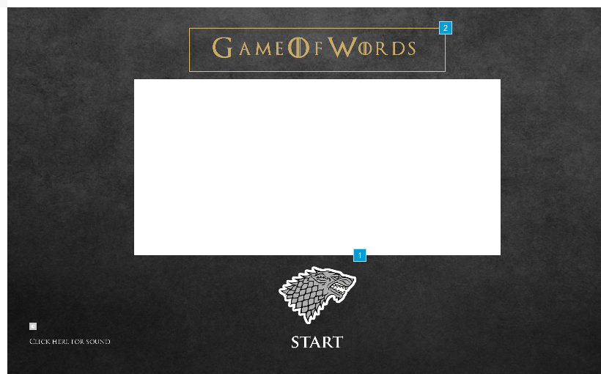

* + 1. Widget Table

|  |  |
| --- | --- |
| Footnote | Interactions |
| 1 | OnClick:  Case 1:  Open Pre Game in Current Window |
| 2 | OnClick:  Case 1:  Open Houses in Current Window |

* 1. Pre Game
     1. User Interface

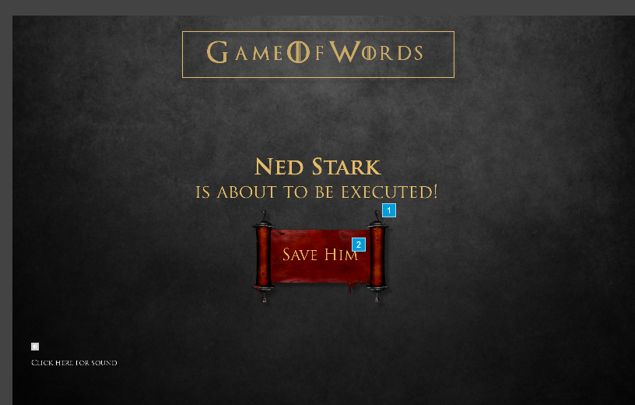

* + 1. Widget Table

|  |  |
| --- | --- |
| Footnote | Interactions |
| 1 | OnClick:  Case 1:  Open Game 1 in Current Window |
| 2 | OnClick:  Case 1:  Open Game 1 in Current Window |

* 1. Game 1
     1. User Interface

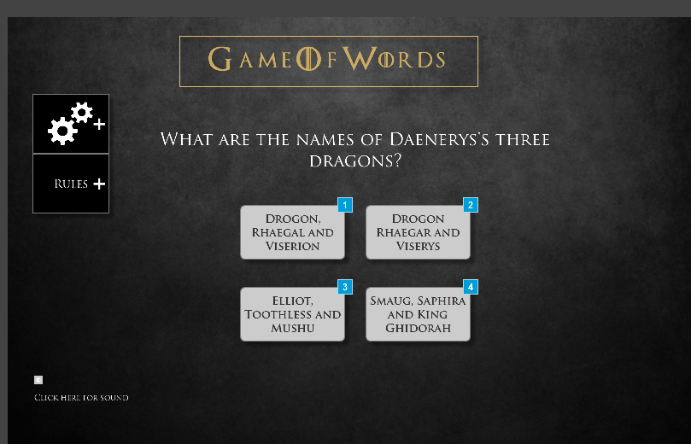

* + 1. Widget Table

|  |  |  |
| --- | --- | --- |
| Footnote | Name | Interactions |
| 1 | A | OnClick:  Case 1:  Open Game 2 in Current Window |
| 2 | option b | OnClick:  Case 1:  Open Pop up for all in Current Window |
| 3 | option c | OnClick:  Case 1:  Open Pop up for all in Current Window |
| 4 | d | OnClick:  Case 1:  Open Pop up for all in Current Window |

* 1. Game 2
     1. User Interface

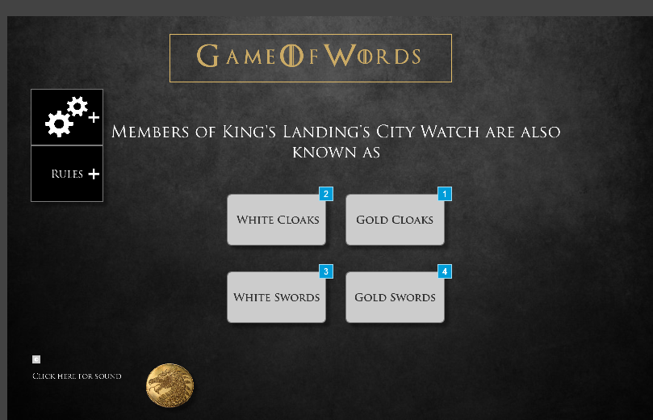

* + 1. Widget Table

|  |  |  |
| --- | --- | --- |
| Footnote | Name | Interactions |
| 1 | option b | OnClick:  Case 1:  Open Game 3 in Current Window |
| 2 | option a | OnClick:  Case 1:  Open Pop up for all in Current Window |
| 3 | option c | OnClick:  Case 1:  Open Pop up for all in Current Window |
| 4 | option d | OnClick:  Case 1:  Open Pop up for all in Current Window |

* 1. Game 3
     1. User Interface

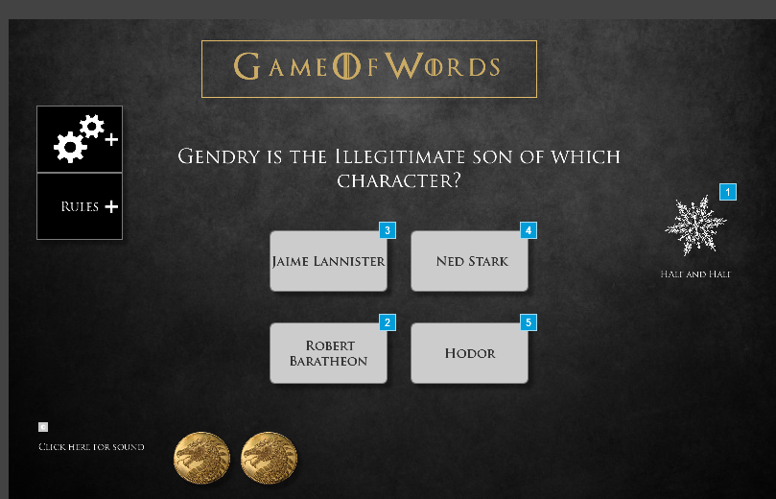

* + 1. Widget Table

|  |  |  |
| --- | --- | --- |
| Footnote | Name | Interactions |
| 1 | Power Up option | OnClick:  Case 1:  Hide Option A, Option B  Hide Power Up option fade 500 ms |
| 2 | Option C | OnClick:  Case 1:  Open Game 4 in Current Window |
| 3 | Option A | OnClick:  Case 1:  Open Pop up for all in Current Window |
| 4 | Option B | OnClick:  Case 1:  Open Pop up for all in Current Window |
| 5 | Option D | OnClick:  Case 1:  Open Pop up for all in Current Window |

* 1. Game 4
     1. User Interface

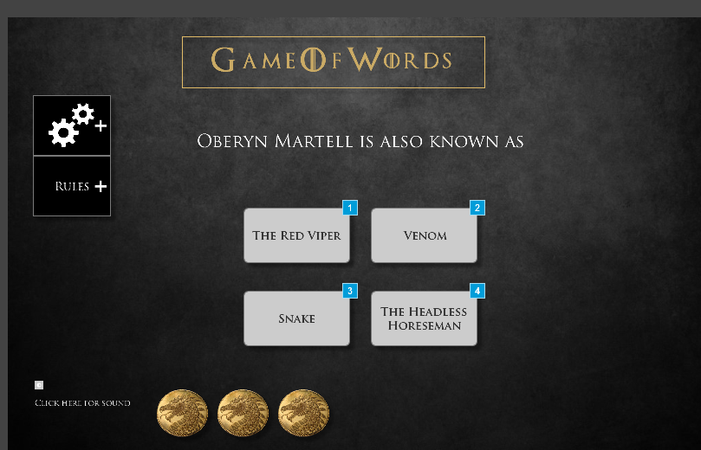

* + 1. Widget Table

|  |  |
| --- | --- |
| Footnote | Interactions |
| 1 | OnClick:  Case 1:  Open Game 5 in Current Window |
| 2 | OnClick:  Case 1:  Open Pop up for all in Current Window |
| 3 | OnClick:  Case 1:  Open Pop up for all in Current Window |
| 4 | OnClick:  Case 1:  Open Pop up for all in Current Window |

* 1. Game 5
     1. User Interface

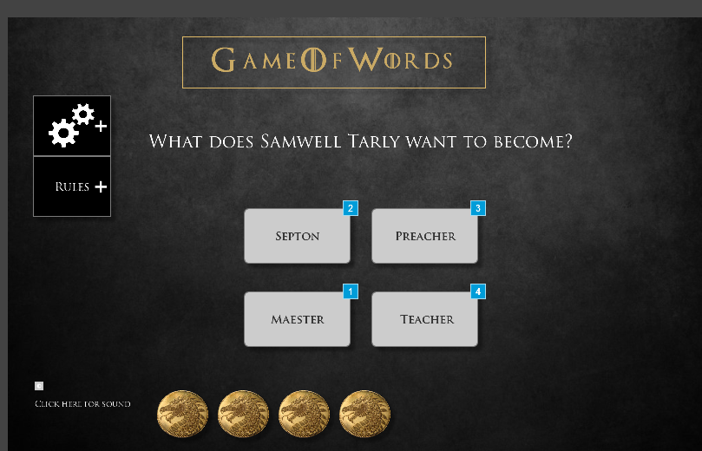

* + 1. Widget Table

|  |  |  |
| --- | --- | --- |
| Footnote | Name | Interactions |
| 1 | right answer | OnClick:  Case 1:  Open Game 6 in Current Window |
| 2 | a | OnClick:  Case 1:  Open Pop up for all in Current Window |
| 3 | b | OnClick:  Case 1:  Open Pop up for all in Current Window |
| 4 | d | OnClick:  Case 1:  Open Pop up for all in Current Window |

* 1. Game 6
     1. User Interface

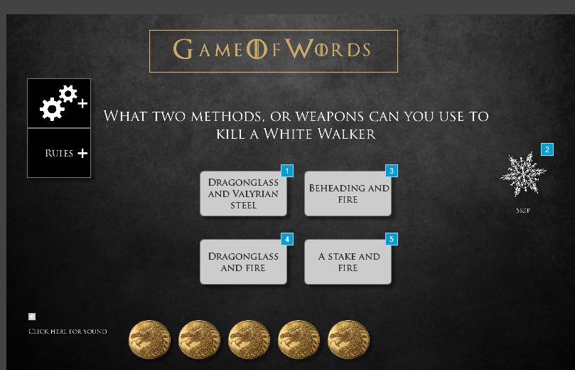

* + 1. Widget Table

|  |  |  |
| --- | --- | --- |
| Footnote | Name | Interactions |
| 1 | right answer | OnClick:  Case 1:  Open Game 7 in Current Window |
| 2 | Power Up option | OnClick:  Case 1:  Open Game 7 in Current Window |
| 3 |  | OnClick:  Case 1:  Open Pop up for all in Current Window |
| 4 |  | OnClick:  Case 1:  Open Pop up for all in Current Window |
| 5 |  | OnClick:  Case 1:  Open Pop up for all in Current Window |

* 1. Game 7
     1. User Interface

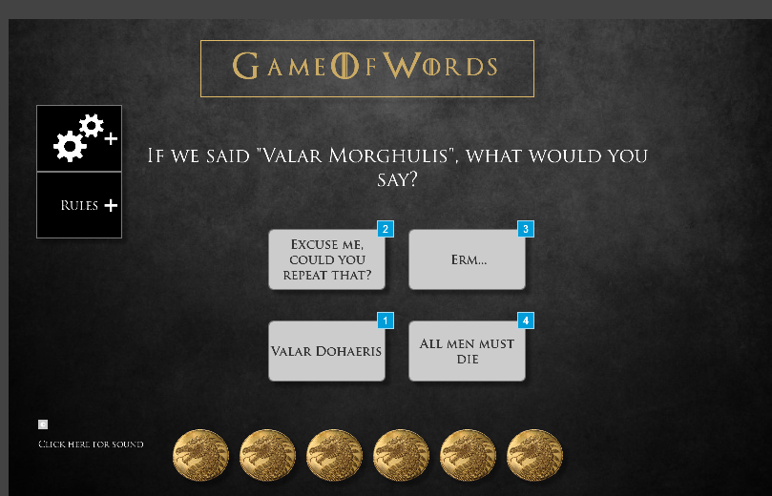

* + 1. Widget Table

|  |  |  |
| --- | --- | --- |
| Footnote | Name | Interactions |
| 1 |  | OnClick:  Case 1:  Open Game 8 in Current Window |
| 2 | a | OnClick:  Case 1:  Open Pop up for all in Current Window |
| 3 | b | OnClick:  Case 1:  Open Pop up for all in Current Window |
| 4 | d | OnClick:  Case 1:  Open Pop up for all in Current Window |

* 1. Game 8
     1. User Interface

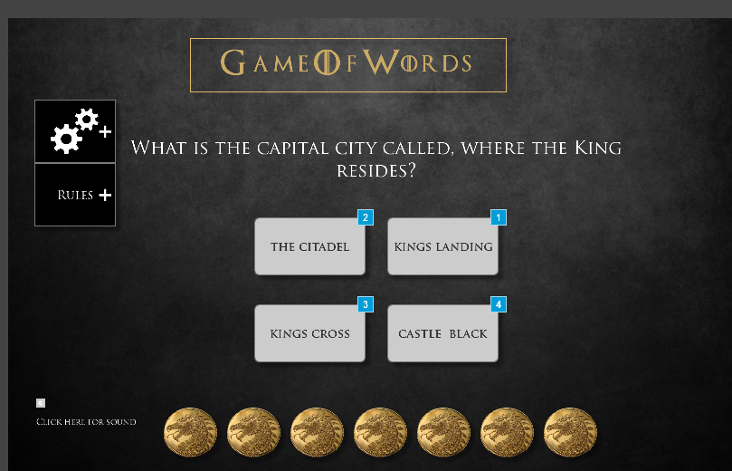

* + 1. Widget Table

|  |  |  |
| --- | --- | --- |
| Footnote | Name | Interactions |
| 1 | right answer | OnClick:  Case 1:  Open Game 9 in Current Window |
| 2 | a | OnClick:  Case 1:  Open Pop up for all in Current Window |
| 3 | c | OnClick:  Case 1:  Open Pop up for all in Current Window |
| 4 | d | OnClick:  Case 1:  Open Pop up for all in Current Window |

* 1. Game 9
     1. User Interface

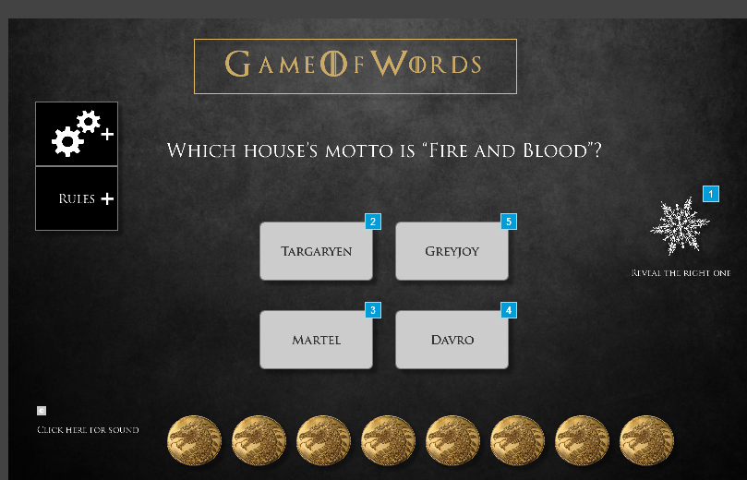

* + 1. Widget Table

|  |  |  |
| --- | --- | --- |
| Footnote | Name | Interactions |
| 1 | Power Up option | OnClick:  Case 1:  Hide wrong 1 fade 500 ms, w 2 fade 500 ms, w 3 fade 500 ms, Power Up option fade 500 ms |
| 2 | Right answer | OnClick:  Case 1:  Open Game 10 in Current Window |
| 3 | w 2 | OnClick:  Case 1:  Open Pop up for all in Current Window |
| 4 | w 3 | OnClick:  Case 1:  Open Pop up for all in Current Window |
| 5 | wrong 1 | OnClick:  Case 1:  Open Pop up for all in Current Window |

* 1. Game 10
     1. User Interface

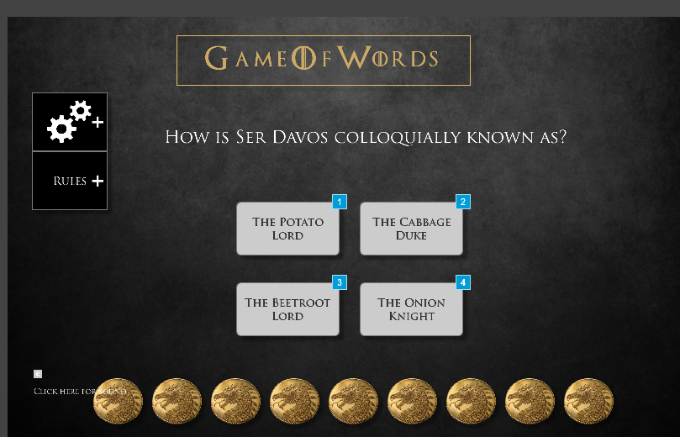

* + 1. Widget Table

|  |  |  |
| --- | --- | --- |
| Footnote | Name | Interactions |
| 1 | w1 | OnClick:  Case 1:  Open Pop up for all in Current Window |
| 2 | w2 | OnClick:  Case 1:  Open Pop up for all in Current Window |
| 3 | w3 | OnClick:  Case 1:  Open Pop up for all in Current Window |
| 4 | right answer | OnClick:  Case 1:  Open Winning Pop up in Current Window |

* 1. Dashboard
     1. User Interface



* + 1. Widget Table

|  |  |
| --- | --- |
| Footnote | Interactions |
| 1 | OnClick:  Case 1:  Open Link in Current Window |
| 2 | OnClick:  Case 1:  Open https://my.uncc.edu/ in Current Window |
| 3 | OnClick:  Case 1:  Open Subscription in Current Window |
| 4 | OnClick:  Case 1:  Open Houses in Current Window |

* 1. Pop up for all
     1. User Interface

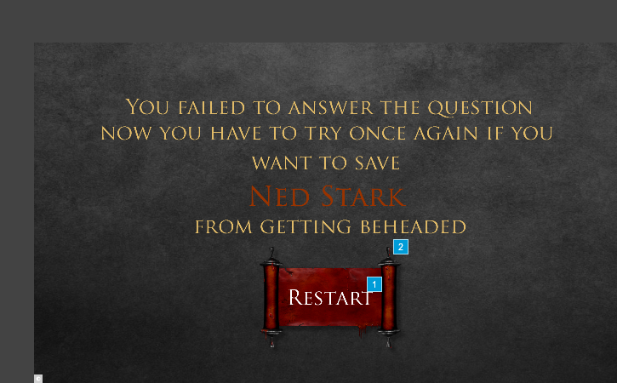

* + 1. Widget Table

|  |  |
| --- | --- |
| Footnote | Interactions |
| 1 | OnClick:  Case 1:  Open Pre Game in Current Window |
| 2 | OnClick:  Case 1:  Open Pre Game in Parent Window  Close Current Window |

* 1. Winning Pop up
     1. User Interface

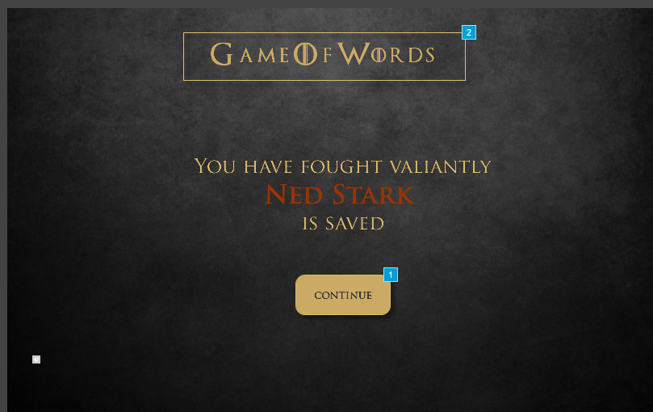

* + 1. Widget Table

|  |  |
| --- | --- |
| Footnote | Interactions |
| 1 | OnClick:  Case 1:  Open Dashboard in Current Window |
| 2 | OnClick:  Case 1:  Open Houses in Current Window |

* 1. Subscription
     1. User Interface

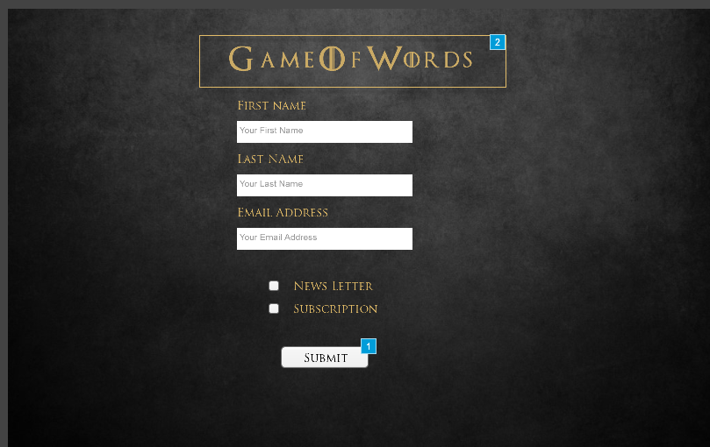

* + 1. Widget Table

|  |  |  |
| --- | --- | --- |
| Footnote | Name | Interactions |
| 1 |  | OnClick:  Case 1:  Set value of FirstNameValu equal to text on First name field, and  value of LastNameValue equal to text on LAst name field, and  value of EmailValue equal to text on email field  Open After Subs in Current Window |
| 2 |  | OnClick:  Case 1:  Open Houses in Current Window |

* 1. After Subs

OnPageLoad:  
 Case 1:  
 Set text on Message equal to "Thanks a lot [[FirstNameValu]][[LastNameValue]] for your subscription you will receive the mailin your mail ID [[EmailValue]]"

* + 1. User Interface

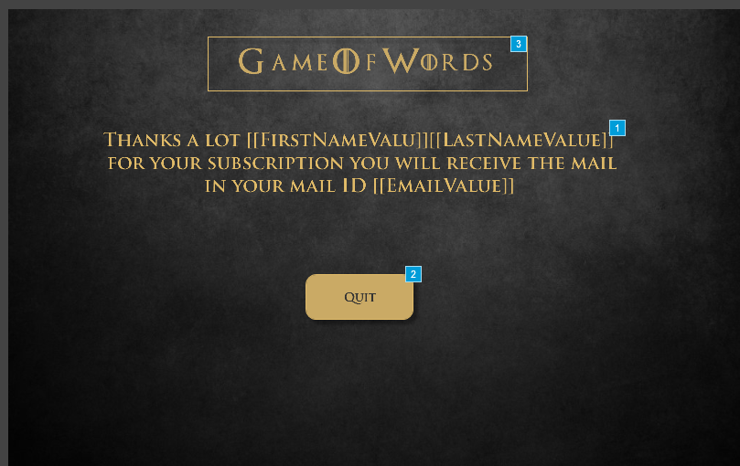

* + 1. Widget Table

|  |  |  |
| --- | --- | --- |
| Footnote | Name | Interactions |
| 1 | Message | OnClick:  Case 1  (If text on Message equals "Thanks a lot [[FirstNameValu]] [[LastNameValue]] for subscription you will receive mail to your mail ID : [[EmailValue]]"):  Set value of FirstNameValu equal to text on Message  Show Message |
| 2 |  | OnClick:  Case 1:  Open Main Home in Current Window |
| 3 |  | OnClick:  Case 1:  Open Houses in Current Window |

* 1. Theories
     1. User Interface

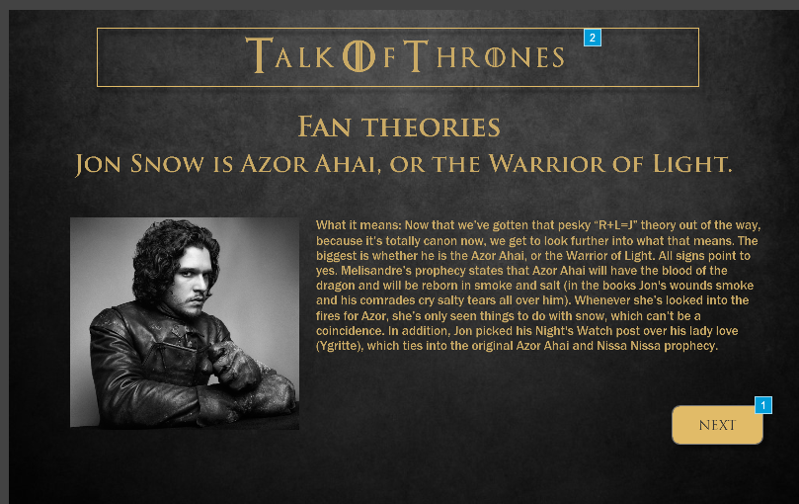

* + 1. Widget Table

|  |  |
| --- | --- |
| Footnote | Interactions |
| 1 | OnClick:  Case 2:  Open Theory 2 in Current Window |
| 2 | OnClick:  Case 1:  Open Main Home in Current Window |

* 1. Theory 2
     1. User Interface

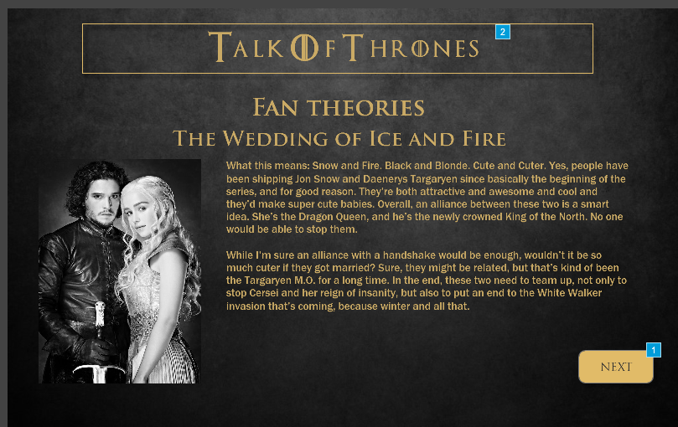

* + 1. Widget Table

|  |  |
| --- | --- |
| Footnote | Interactions |
| 1 | OnClick:  Case 2:  Open Theory 3 in Current Window |
| 2 | OnClick:  Case 1:  Open Main Home in Current Window |

* 1. Theory 3
     1. User Interface

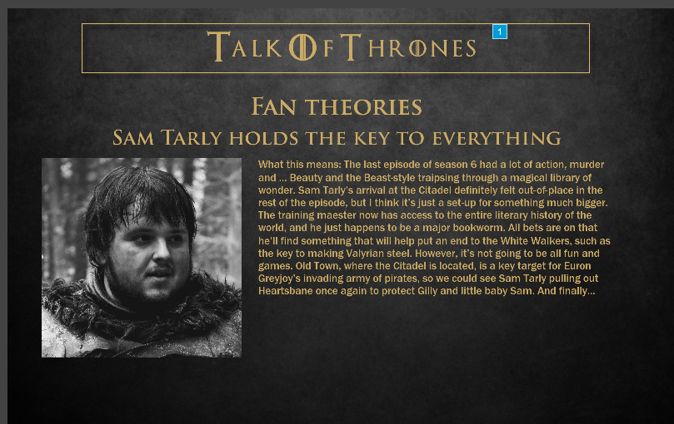

* + 1. Widget Table

|  |  |
| --- | --- |
| Footnote | Interactions |
| 1 | OnClick:  Case 1:  Open Main Home in Current Window |

* 1. Shopping Page
     1. User Interface

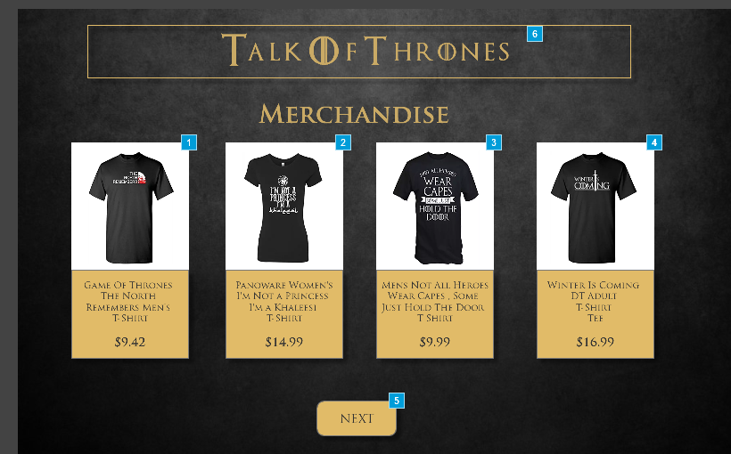

* + 1. Widget Table

|  |  |
| --- | --- |
| Footnote | Interactions |
| 1 | OnClick:  Case 1:  Open Cart in Current Window |
| 2 | OnClick:  Case 1:  Open Cart in Current Window |
| 3 | OnClick:  Case 1:  Open Cart in Current Window |
| 4 | OnClick:  Case 1:  Open Cart in Current Window |
| 5 | OnClick:  Case 1:  Open Shopping Page 2 in Current Window |
| 6 | OnClick:  Case 1:  Open Main Home in Current Window |

* 1. Shopping Page 2
     1. User Interface

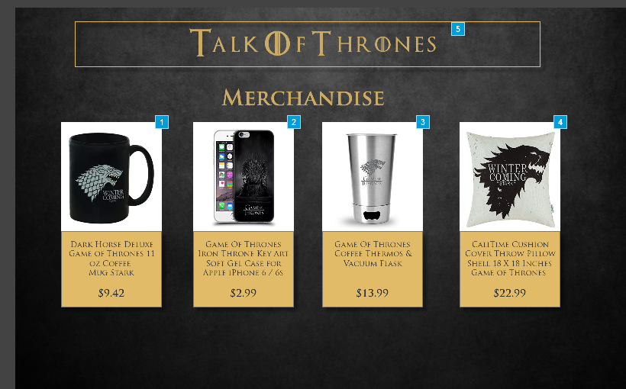

* + 1. Widget Table

|  |  |
| --- | --- |
| Footnote | Interactions |
| 1 | OnClick:  Case 1:  Open Cart in Current Window |
| 2 | OnClick:  Case 1:  Open Cart in Current Window |
| 3 | OnClick:  Case 1:  Open Cart in Current Window |
| 4 | OnClick:  Case 1:  Open Cart in Current Window |
| 5 | OnClick:  Case 1:  Open Main Home in Current Window |

* 1. Cart
     1. User Interface

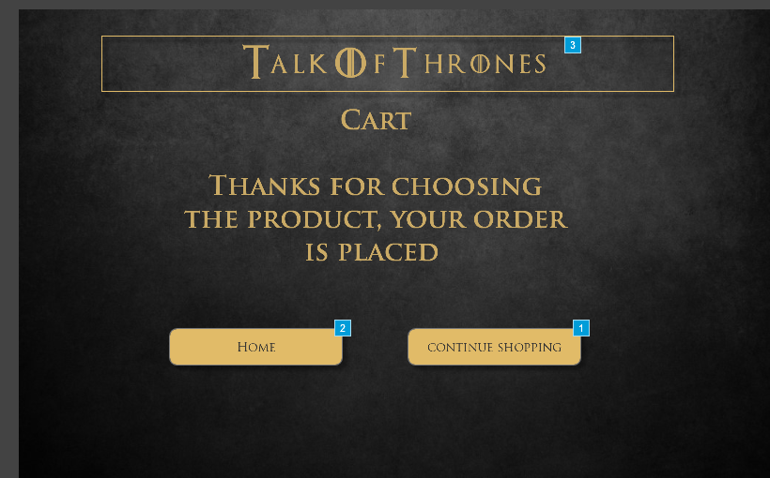

* + 1. Widget Table

|  |  |
| --- | --- |
| Footnote | Interactions |
| 1 | OnClick:  Case 1:  Open Shopping Page in Current Window |
| 2 | OnClick:  Case 1:  Open Main Home in Current Window |
| 3 | OnClick:  Case 1:  Open Main Home in Current Window |

* 1. Chat
     1. User Interface

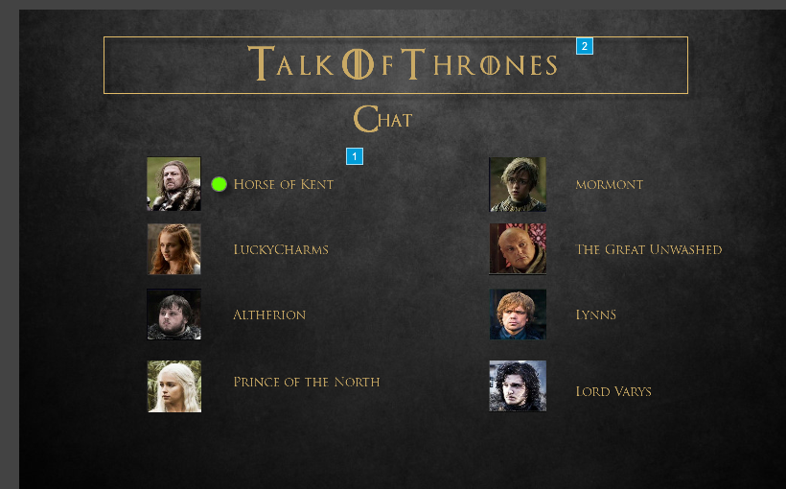

* + 1. Widget Table

|  |  |
| --- | --- |
| Footnote | Interactions |
| 1 | OnClick:  Case 1:  Open Chat page in Current Window |
| 2 | OnClick:  Case 1:  Open Main Home in Current Window |

* 1. Chat page
     1. User Interface

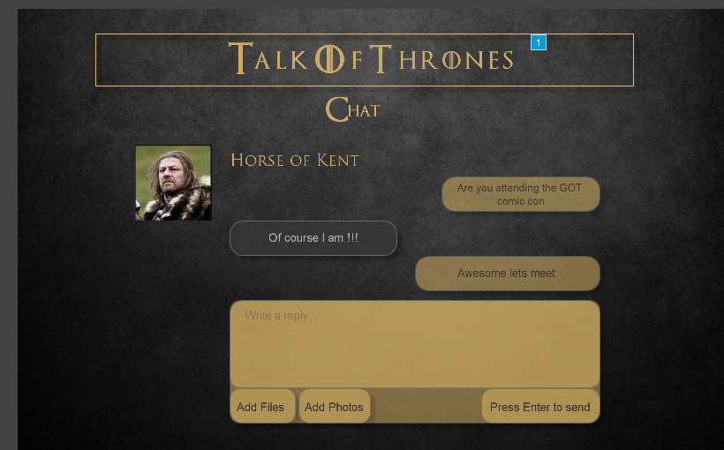

* + 1. Widget Table

|  |  |
| --- | --- |
| Footnote | Interactions |
| 1 | OnClick:  Case 1:  Open Main Home in Current Window |

* 1. Assistance
     1. User Interface

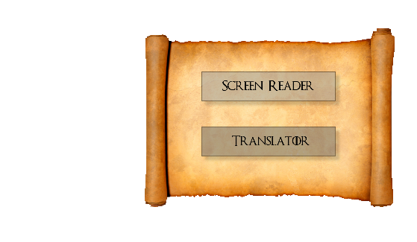

1. Masters
   1. Master List

Wow Master  
Game panel  
Copy of Game panel  
Pre Game Panel  
Sound  
Dashboard  
Winning Pop Up  
Subcription

* 1. Wow Master
  2. Game panel
     1. User Interface

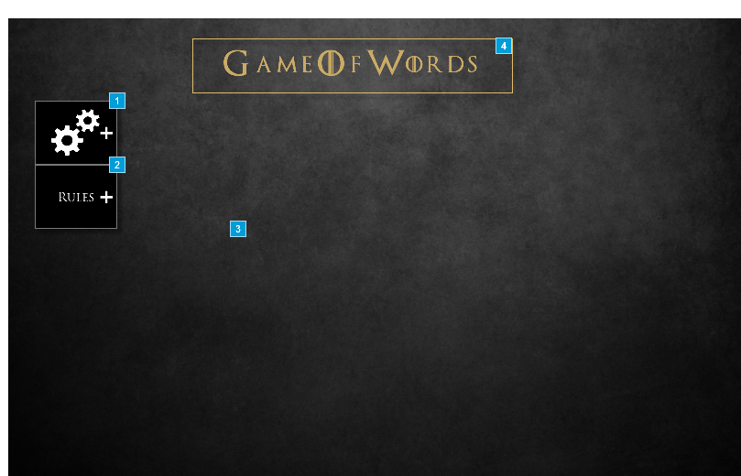

* + 1. Widget Table

|  |  |  |
| --- | --- | --- |
| Footnote | Name | Interactions |
| 1 | Settings | OnClick:  Case 1:  Toggle DropdownOptions push/pull widgets below elastic 500ms  Set Settings to Next wrap |
| 2 | Hints | OnClick:  Case 1:  Toggle Hintsdropdown fade 500 ms  Set Hints to Next wrap |
| 3 | Hintsdropdown | OnLoad:  Case 1:  Scroll to (Shape) (y only) bounce 500ms |
| 4 |  | OnClick:  Case 1:  Open Houses in Current Window |

* + 1. Settings
       1. State 1
       2. User Interface



* + - 1. State 2
      2. User Interface



* + 1. DropdownOptions
       1. State1
       2. User Interface



* + - 1. Widget Table

|  |  |
| --- | --- |
| Footnote | Interactions |
| 1 | OnClick:  Case 1:  Open Main page |
| 2 | OnClick:  Case 1:  Open Page Setup in Popup Window |
| 3 | OnClick:  Case 1:  Open http://www.dictionary.com/ in Popup Window |

* + 1. Hints
       1. State1
       2. User Interface

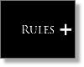

* + - 1. State2
      2. User Interface

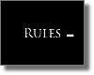

* + 1. Hintsdropdown
       1. State1
       2. User Interface

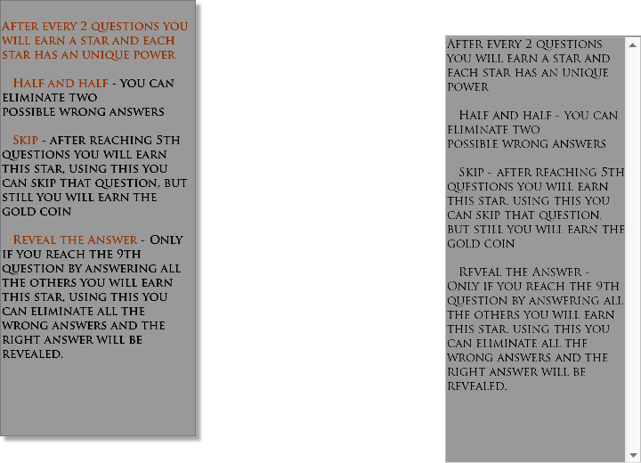

* 1. Copy of Game panel
     1. User Interface

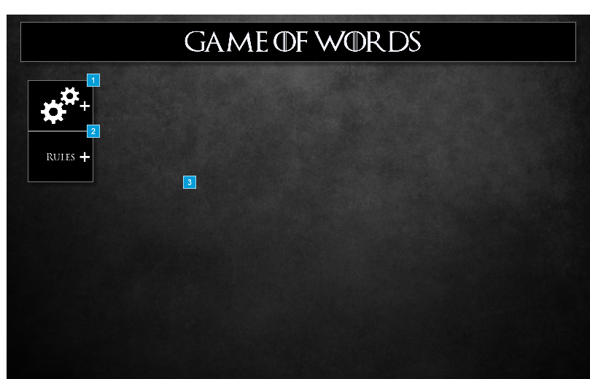

* + 1. Widget Table

|  |  |  |
| --- | --- | --- |
| Footnote | Name | Interactions |
| 1 | Settings | OnClick:  Case 1:  Toggle DropdownOptions push/pull widgets below elastic 500ms  Set Settings to Next wrap |
| 2 | Hints | OnClick:  Case 1:  Toggle Hintsdropdown fade 500 ms  Set Hints to Next wrap |
| 3 | Hintsdropdown | OnLoad:  Case 1:  Scroll to (Shape) (y only) bounce 500ms |

* + 1. Settings
       1. State 1
       2. User Interface



* + - 1. State 2
      2. User Interface



* + 1. DropdownOptions
       1. State1
       2. User Interface



* + - 1. Widget Table

|  |  |
| --- | --- |
| Footnote | Interactions |
| 1 | OnClick:  Case 1:  Open Link in Current Window |
| 2 | OnClick:  Case 1:  Open Page Setup in Popup Window |
| 3 | OnClick:  Case 1:  Open http://www.dictionary.com/ in Popup Window |

* + 1. Hints
       1. State1
       2. User Interface



* + - 1. State2
      2. User Interface



* + 1. Hintsdropdown
       1. State1
       2. User Interface



* 1. Pre Game Panel
     1. User Interface



* + 1. Widget Table

|  |  |
| --- | --- |
| Footnote | Interactions |
| 1 | OnClick:  Case 1:  Open Houses in Current Window |

* 1. Sound
     1. User Interface



* 1. Dashboard
     1. User Interface



* + 1. Widget Table

|  |  |
| --- | --- |
| Footnote | Interactions |
| 1 | OnClick:  Case 1:  Open Shopping Page in Current Window |
| 2 | OnClick:  Case 1:  Open Theories in Current Window |
| 3 | OnClick:  Case 1:  Open Main Home in Current Window |
| 4 | OnClick:  Case 1:  Open Home in Current Window |
| 5 | OnClick:  Case 1:  Open Chat in Current Window |
| 6 | OnClick:  Case 1:  Show (Dynamic Panel) |

* + 1. Unnamed
       1. State1
       2. User Interface

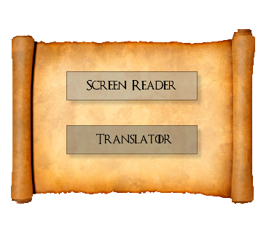

* 1. Winning Pop Up
     1. User Interface



* + 1. Widget Table

|  |  |
| --- | --- |
| Footnote | Interactions |
| 1 | OnClick:  Case 1:  Open Houses in Current Window |

* 1. Subcription
     1. User Interface

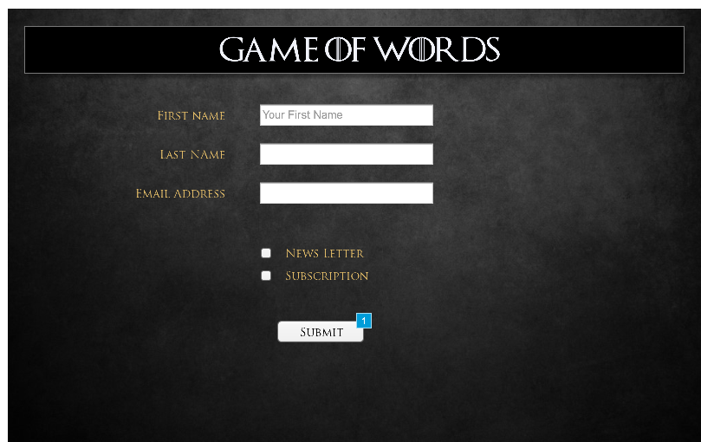

* + 1. Widget Table

|  |  |  |
| --- | --- | --- |
| Footnote | Name | Interactions |
| 1 |  | OnClick:  Case 1:  Set value of FirstNameValu equal to text on First name field, and  value of LastNameValue equal to text on LAst name field, and  value of EmailValue equal to text on email field |